Last Updated: 11/07/2023

This guide outlines the steps required to request Time Off. Note: The Time Off request feature does not replace conversations and planning between employees and supervisors.

Contents
Accessing SuccessFactors 1
Note for Employees with Multiple Appointments 1
Request Time Off Quick Action Tile 2
Time Off: Viewing, Editing or Cancelling 4
Balance Overview 5

Accessing SuccessFactors
Select Employee Launchpad (SuccessFactors) from OneCampus or other website connection.  Log in with username and password. |  | 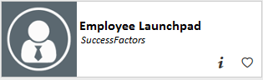

Note for Employees with Multiple Appointments
If you hold multiple positions, use the Change Selected Employment menu to select the position for which you would like to request time off. |  | 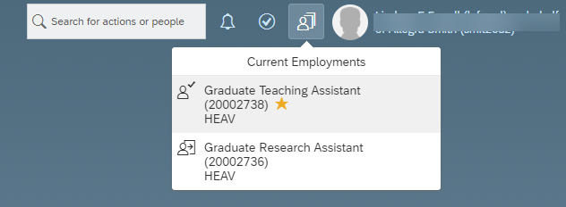
If you hold multiple positions and they are similarly named, click My Profile to validate that the correct position has been selected. |  | 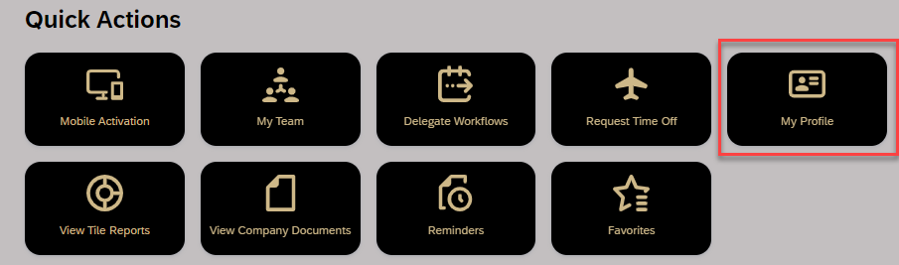
Then click the Employment Information tab to view the details of the position selected in order to ensure time off is requested for the correct position.  Click the Home icon at the top of the page to return to the SuccessFactors home page.   |  | 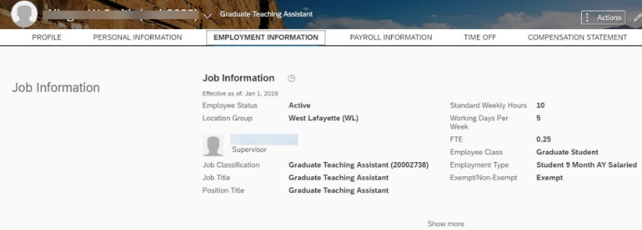

Request Time Off Quick Action Tile
Select the Request Time Off Quick Action Tile. |  | 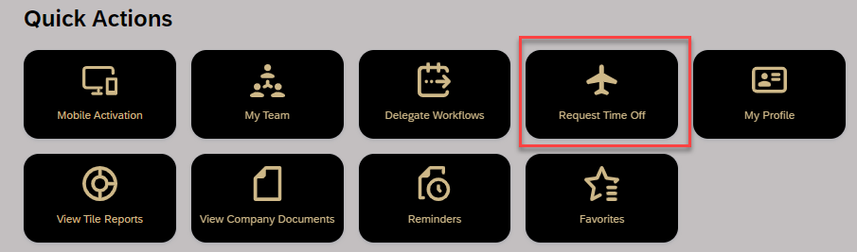
- Select the appropriate Time Type (vacation, sick, personal, volunteer, bereavement, jury duty, other leave with pay or unpaid)  - Select Start and End Date  - Type hours in Requesting field.  - Add Comment or upload Attachment, if applicable  - Click Submit |  | 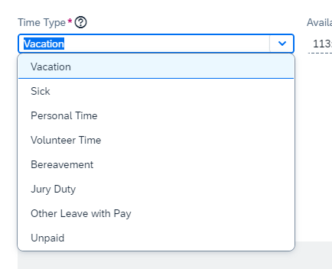  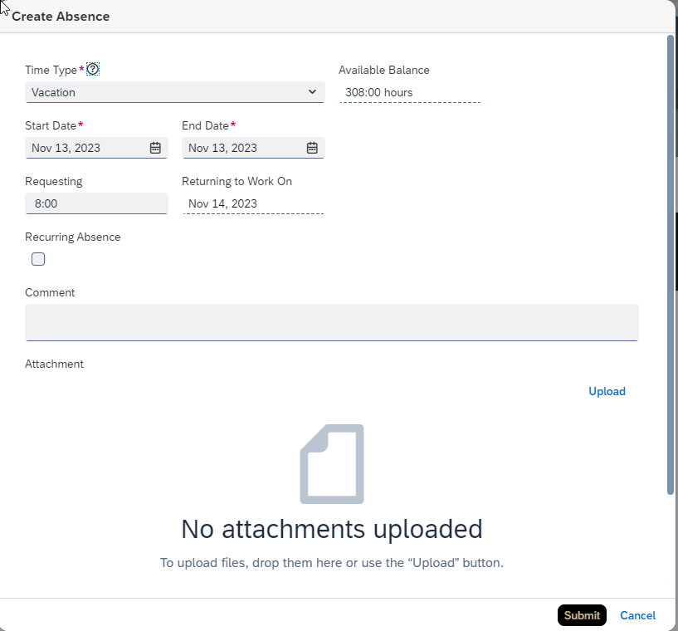
Additional Notes about Requesting Hours:
- Non-exempt employees can request partial time off in hours and tenths.
- Example: Seth would like to request vacation for half a day on Wednesday and all of Thursday and Friday. Seth must submit one request for the Wednesday half day and another for the full days, Thursday and Friday.
- Employees who utilize the Positive Time Entry Method are encouraged to wait until they have recorded their working time for the day on which they plan to request partial Time Off before submitting their Time Off request. This will avoid errors and need to re-submit requests if the amount of working time is more or less than expected.
Recurring Absence Information:  Recurring Absence is used when needing to take partial days or a specific increment of hours over several days.  - Click to check the Recurring Absence box.  - Select daily, weekly or biweekly from the Recurs drop-down.  - Validate the Requesting hours is correct (the system defaults to 8 hours.)  Type or select the date the leave Ends on. |  | 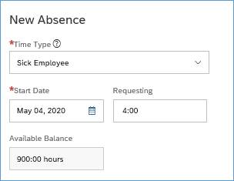  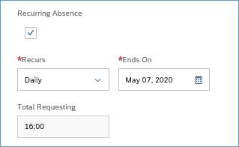
To view additional details such as a calendar, request status or access Team Absences, scroll to the bottom of the request and click Time Off. |  | 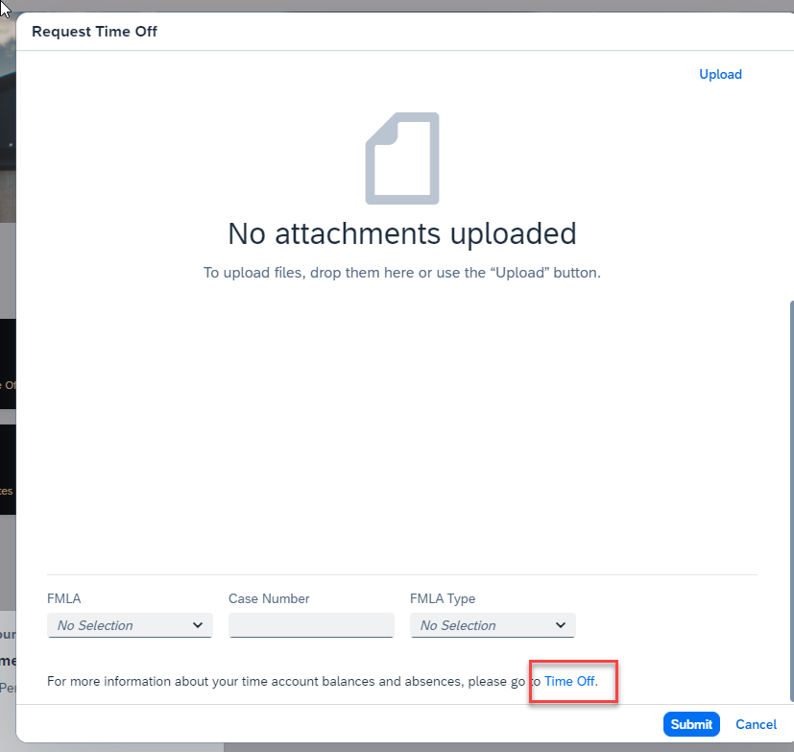
This will display a two-month calendar, legend, balances and more.
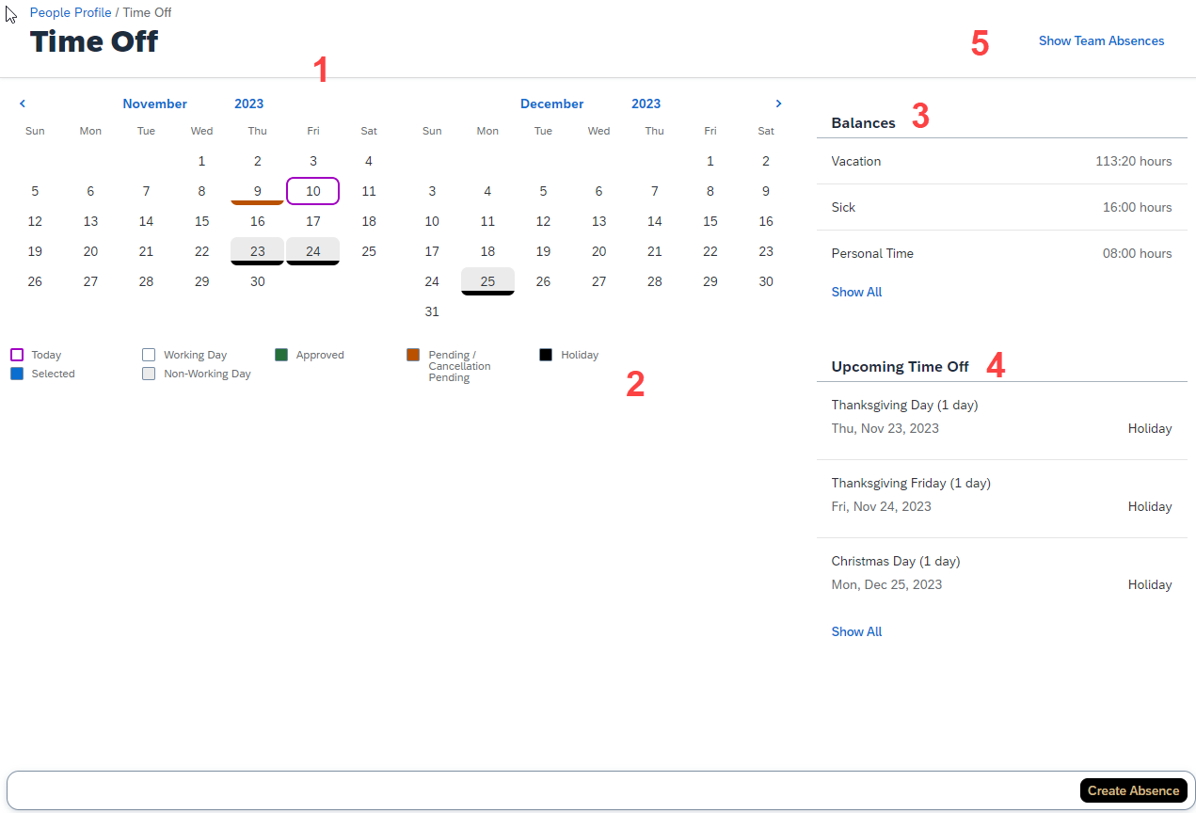
- Calendar |  | This is displayed after clicking Time Off towards the bottom of the Quick Action. Displays the current and next month; dates with scheduled time off are indicated by colored bar.
- Calendar Legend |  | Describes each color notation that indicate various leave statuses – such as approved, pending or holiday.
- Balances |  | Displays Vacation, Sick and Personal Time balances as of today’s date. Please note: The system will allow you to request up to 80 hours not currently banked at the time that you are submitting the request.
- Upcoming Time Off |  | Displays the next three time Absense and Holiday time off entries.
- Show Team Absences |  | Once clicked, it will display your team members and if they have requests by day, week or month.  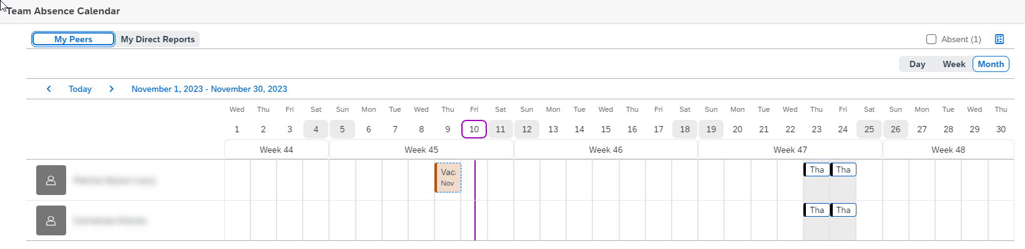

Time Off: Viewing, Editing or Cancelling
The submitted request can be viewed and accessed by clicking the Date on the Calendar, or by clicking the Absence listed under the Upcoming Time Off heading. |  | 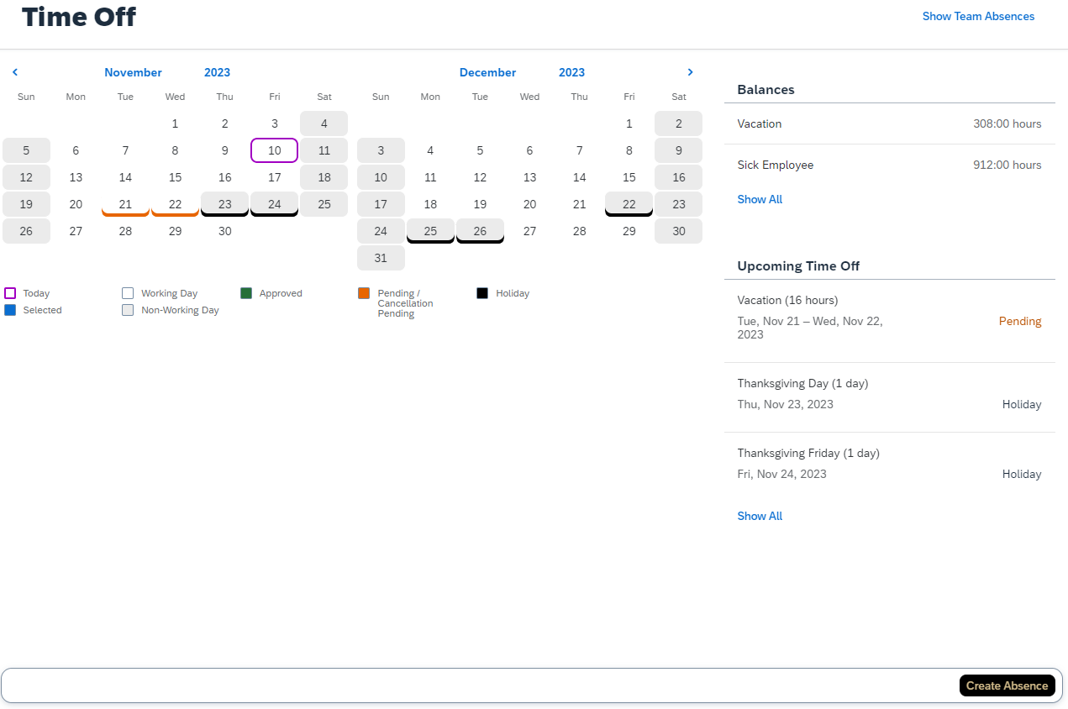
To edit a request, you can use the Calendar, click the Pencil icon to edit.  If accessing through Upcoming Time Off, click the request to open the Edit Absence. |  | 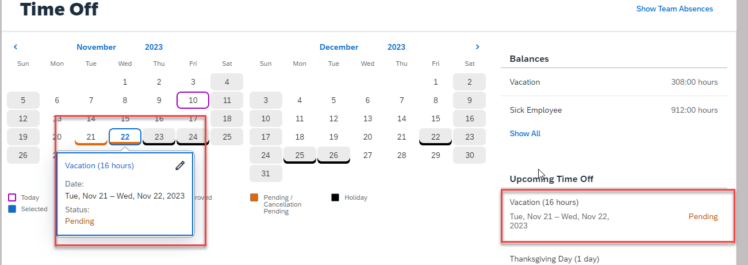
Make necessary edits to the request.  Click Submit or Cancel Absence (if cancelling).  NOTE: The edited request will be routed for approval only if the original request was already approved. |  | 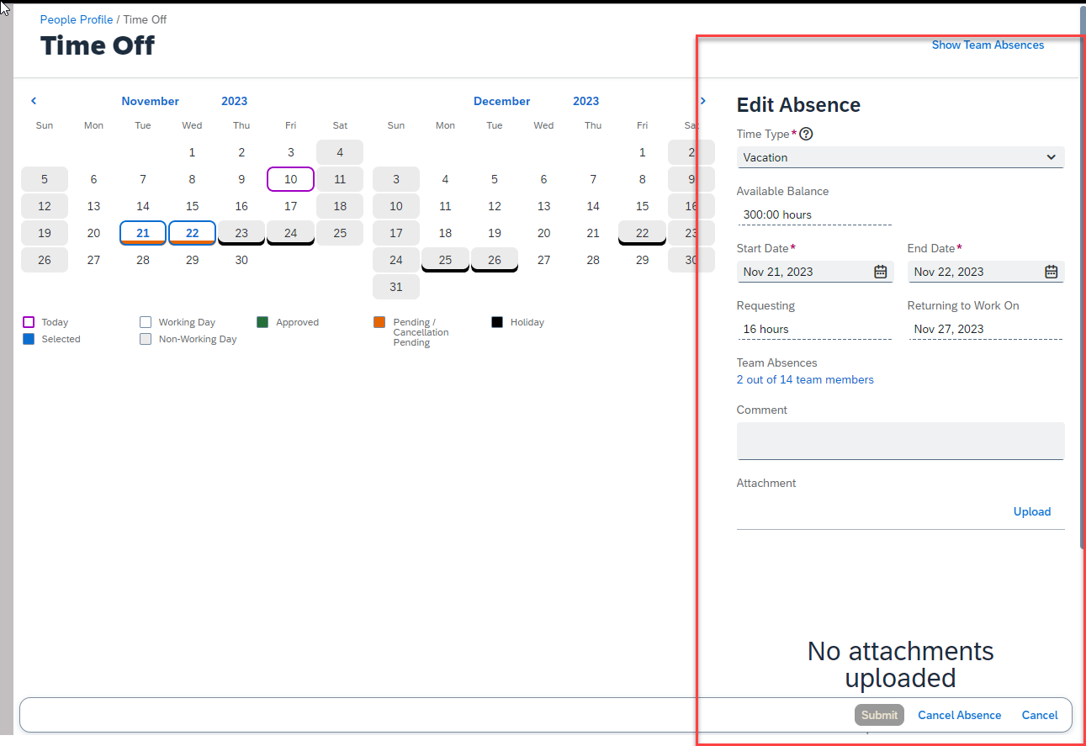
If cancelling, click Yes, to confirm |  | 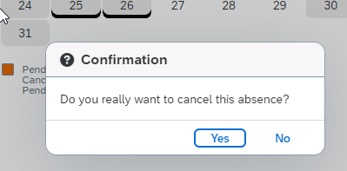

Balance Overview
Vacation, Sick and Personal Time balances are as of today’s date are listed under the Balances heading on the top right of the screen.  Click Show All to view additional leave types.  To view leave balances as of a future date, click the As of Today button.  - Select a date past any future approved leaves to view your “true” balances (less any future takings).  - NOTE: Moving the date will not add to the balances due to projected accruals. | 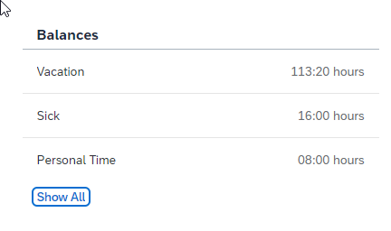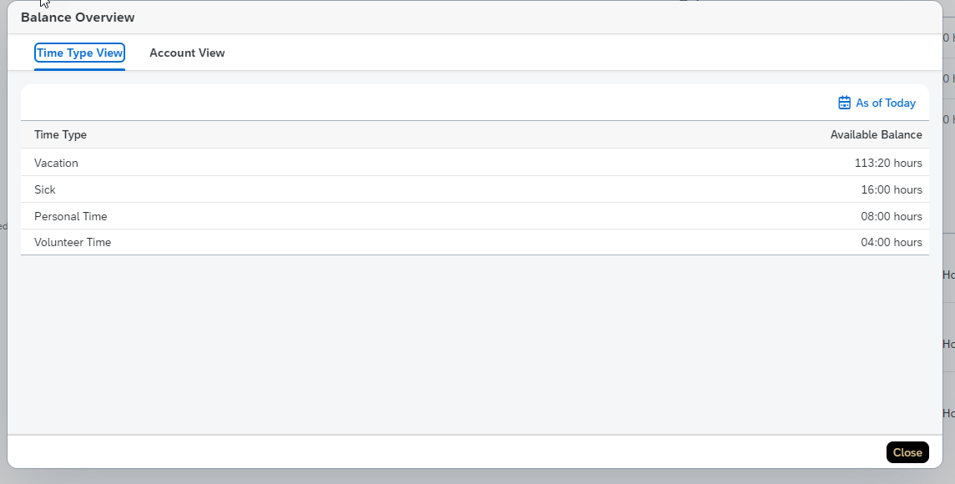  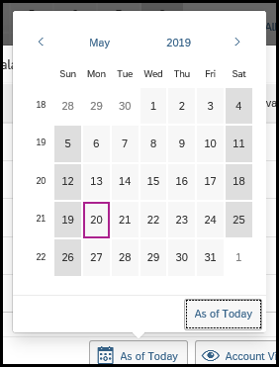
Balance Overview allows you to view Time Type View and Account View.  It displays Earned, Taken, Planned, and Available. | 